Experiment1.4

Student Name: Himanshu UID: 20BCS7944
Branch: CSE Section: 905/A
Semester: 6 Date of Performance: 23/03/2023
Subject Name: IOT Lab Subject Code: 20CSP-358

1) Aim:

Program to interface the Arduino/Raspberry Pi with LED and blinking application.

2) Objective:

Learn about interfacing.

Testing the model in IoT based simulation platform.

3) Apparatus / Simulator used:

      - 1 × Breadboard
      - 1 × Breadboard
  - 1 × Arduino Uno R3
  - 1 × LED
  - 1 × 330Ω Resistor
  - 2 × Jumper

4) Theory:
LEDs are small, powerful lights that are used in many different applications. To start, we will work on blinking an LED, the Hello World of micro controllers.
It is as simple as turning a light on and off. Establishing this important baseline will giveyou a solid foundation as we work towards experiments that are more complex.
Arduino is a project, open-source hardware, and software platform used to design andbuild electronic devices. It designs and manufactures microcontroller kits and single- board interfaces for building electronics projects.

5) Code:
int ledPin=8;
void setup(){
pinMode(ledPin,OUTPUT);
}
void loop(){
digitalWrite(ledPin,HIGH);
delay(1000);
digitalWrite(ledPin,LOW);
delay(1000);
}

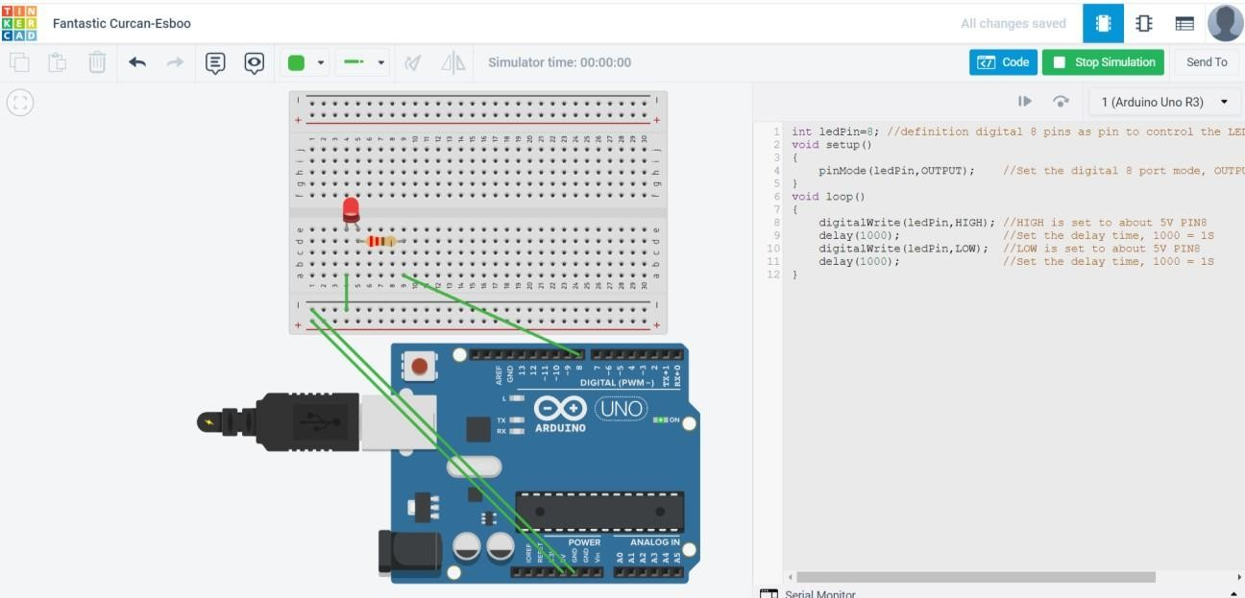
6) Output:

